### **Circuit Switching Examples**

Examples of circuit switching are:

* Analog telephone network
* Optical mesh network
* Public Switched Telephone Network (PSTN)

## **Phases of Circuit Switching**

### 

### **Circuit Establishment**

A dedicated circuit between the source and the destination is established with the help of numerous intermediate switching centres. The requesting and receiving of the communication signals are possible when the sender and receiver transmit signals across the circuit.

### **Data Transfer**

The transfer of data and voice signals are possible between the source and the destination after the establishment of the circuit. The connection between both the end parties continues as long as they communicate.

### **Circuit Disconnection**

The disconnection in the circuit happens when one of the users initiates to disconnect. When the disconnection takes place, all the intermediate links between the sender and receiver are removed.

**Packet Switching** in computer networks is a method of transferring data to a network in the form of packets. In order to transfer the file fast and efficiently over the network and minimize the transmission latency, the data is broken into small pieces of variable length, called **Packet**. At the destination, all these small parts (packets) have to be reassembled, belonging to the same file. A packet is composed of a payload and various control information. No pre-setup or reservation of resources is needed.

Packet Switching uses the **Store and Forward** technique while switching the packets; while forwarding the packet each hop first stores that packet then forwards. This technique is very beneficial because packets may get discarded at any hop for some reason. More than one path is possible between a pair of sources and destinations. Each packet contains the Source and destination address using which they independently travel through the network. In other words, packets belonging to the same file may or may not travel through the same path. If there is congestion at some path, packets are allowed to choose different paths possible over an existing network.

## Diagram of Packet Switching

In packet switching the data is divided into small packets which allow faster movement of data. Each packet contains two parts that is Header and Payload, the header on each packet conation information. Below is the diagram of how packet switching works.

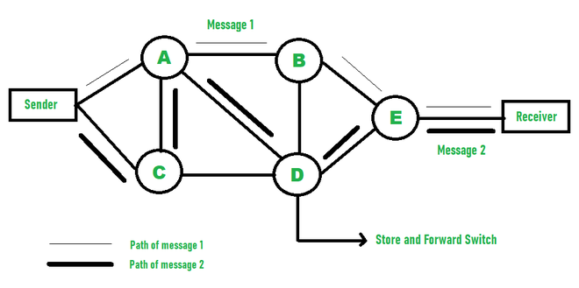

*Packet Switching*

## Types of Delays in Packet Switching

* **Transmission Delay:** Time required by the **spent**station to transmit data to the link.
* **Propagation Delay:**Time of data propagation through the link.
* **Queueing Delay:**Time spent by the packet at the destination’s queue.
* **Processing Delay:** Processing time for data at the destination.

## ****Advantages of Packet Switching over Circuit Switching****

* More efficient in terms of bandwidth, since the concept of reserving a circuit is not there.
* Minimal transmission latency.
* More reliable as a destination can detect the missing packet.
* More fault tolerant because packets may follow a different path in case any link is down, Unlike Circuit Switching.
* Cost-effective and comparatively cheaper to implement.

## ****Disadvantage of Packet Switching over Circuit Switching****

* Packet Switching doesn’t give packets in order, whereas Circuit Switching provides ordered delivery of packets because all the packets follow the same path.
* Since the packets are unordered, we need to provide sequence numbers for each packet.
* Complexity is more at each node because of the facility to follow multiple paths.
* Transmission delay is more because of rerouting.
* Packet Switching is beneficial only for small messages, but for bursty data (large messages) Circuit Switching is better.

## ****Types of Packet Switching****

### ****1. Connection-oriented Packet Switching (Virtual Circuit)****

Before starting the transmission, it establishes a logical path or virtual connection using a signaling protocol, between sender and receiver and all packets belongs to this flow will follow this predefined route. Virtual Circuit ID is provided by switches/routers to uniquely identify this virtual connection. Data is divided into small units and all these small units are appended with help of sequence numbers. Packets arrive in order at the destination. Overall, three phases take place here- The setup, data transfer and tear-down phases.

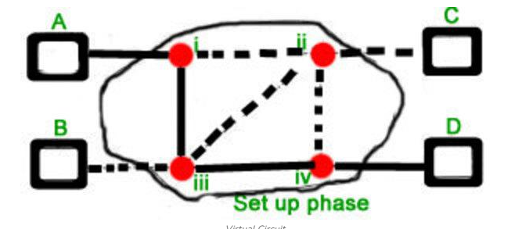

Connection-oriented switching is very useful in switched WAN. Some popular protocols which use the Virtual Circuit Switching approach are X.25, Frame-Relay, ATM, and MPLS(Multi-Protocol Label Switching).

### ****Connectionless Packet Switching (Datagram)****

Unlike Connection-oriented packet switching, In Connectionless Packet Switching each packet contains all necessary addressing information such as source address, destination address, port numbers, etc. Packets belonging to one flow may take different routes because routing decisions are made dynamically, so the packets that arrived at the destination might be out of order. It has no connection setup and teardown phase, like Virtual Circuits.   
Packet delivery is not guaranteed in connectionless packet switching, so reliable delivery must be provided by end systems using additional protocols.

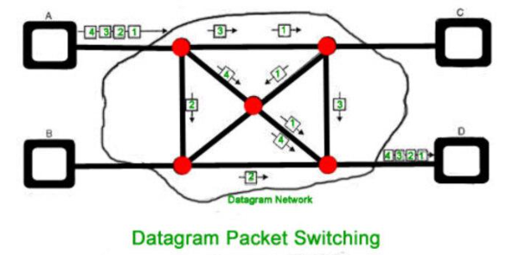

*A—R1—R2—BA is the sender (start)R1, R2 are two routers that store and forward data B is receiver(destination)*

To send a packet from A to B there are delays since this is a Store and Forward network.